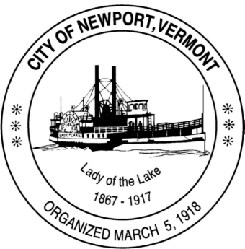

**Special Task Force on Financial Reporting and Fiscal Practices**

**Community Residents are Welcome to Attend**

**City Council Chambers - Newport Municipal Building**

**Organizing Meeting: 4/04/25 at 4 pm**

**Google Meet joining info**

**Video call link: https://meet.google.com/xos-ksyz-snk**

**Or dial: ‪(US) +1 318-431-0727‬ PIN: ‪332 871 542‬#**

**More phone numbers: https://tel.meet/xos-ksyz-snk?pin=5770953319534**

**Task Force Members: Carter Finegan, Laurie Grimm, Travis Gaines, Hal Rodenberg, Suzie Small**

**Staff Support: Jim Johnson, Stacey Therrien**

**Agenda:**

1. **Call to Order**
2. **Introductions**
3. **Discussion Regarding MEMRC Financial Management System**
4. **Open Discussion re: Next Steps**
5. **Review Task List and Necessary Resources**
6. **Adjourn**