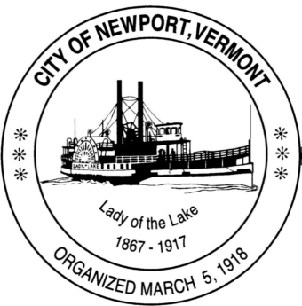

**Special Task Force on Water and Sewer**

**Community Residents are Welcome to Attend**

**City Council Chambers - Newport Municipal Building**

**Organizing Meeting: 04 03 25 at 6:30 pm**

**Google Meet joining info**

**Video call link: https://meet.google.com/mhx-xaxu-gbj**

**Or dial: ‪(US) +1 304-621-9801‬ PIN: ‪676 554 769‬#**

**More phone numbers: https://tel.meet/mhx-xaxu-gbj?pin=5663111283345**

**Task Force Members: John Monette, Paul Tice, Patrick Hurley, Jennifer Hopkins, Carl King**

**Staff Support: Tom Bernier**

**Agenda:**

1. **Call to order**
2. **Distribution of materials available to date from City offices**
3. **Discussion regarding methodology to be used in formulating near term recommendations**
4. **Adjourn**