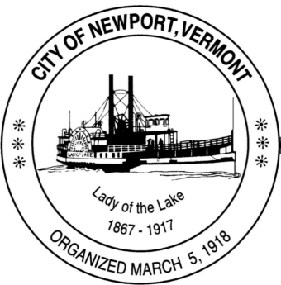

**Special Task Force on Water and Sewer**

**Community Residents are Welcome to Attend**

**City Council Chambers - Newport Municipal Building**

**Organizing Meeting: 3/27/25 at 7:30 pm**

**Task Force Members: John Monette, Paul Tice, Patrick Hurley, Jennifer Hopkins, Carl King**

**Staff Support: Tom Bernier**

**Agenda:**

1. **Call to Order**
2. **Introductions**
3. **Review Charge from City Council**
4. **Discuss/determine what tasks/results are achievable in the near term**
5. **Discuss/make preliminary determination of what information/documentation/support may be needed to accomplish those tasks**
6. **Set Meeting Schedule**
7. **Adjourn**