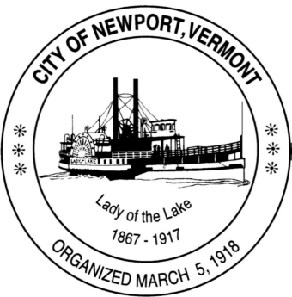

**Special City Council Meeting**

**Thursday, March 20 · 6:00 – 7:30pm**

**Google Meet joining info**

**Video call link: https://meet.google.com/mqn-biji-cea**

**Or dial: ‪(US) +1 252-357-6074‬ PIN: ‪403 980 365‬#**

**More phone numbers: https://tel.meet/mqn-biji-cea?pin=3362329208126**

Mayor: Rick Ufford-Chase

Council Member: President [Kevin Charboneau](mailto:kevin.charboneau@newportvermont.org)

Carter Finegan

Andrew Touchette

1. Call the Meeting to Order
2. Additions/Deletions
3. Consideration and possible action to appoint a Council Member to fill the vacant seat until the Special Election called for May 6, 2025. Possible Executive Session 1 V.S.A. § 313(a)(3)
4. Public Comment
5. New Business
6. Old Business
7. Set the Next meeting of the Council - a Special Called Meeting for March 31, 2025 at 6 pm.
8. Adjournment